Ideation Phase
Brainstorm & Idea Prioritization Template

Date | 19 Febraury 2026
Team ID | LTVIP2026TMIDS41894
Project Name | Plugging into the Future: An Exploration of Electricity Consumption Patterns Using Tableau
Maximum Marks | 4 Marks

Brainstorm & Idea Prioritization Template:
Brainstorming provides a free and open environment that encourages everyone within a team to participate in the creative thinking process that leads to problem solving. Prioritizing volume over value, out-of-the-box ideas are welcome and built upon, and all participants are encouraged to collaborate, helping each other develop a rich amount of creative solutions.
Step-1: Team Gathering, Collaboration and Select the Problem Statement
The team discussed the problem of increasing and uneven electricity consumption across regions, time periods, and sectors.
The key challenge identified was understanding consumption patterns to identify peak demand, seasonal variations, and high-consuming sectors using data visualization tools like Tableau.
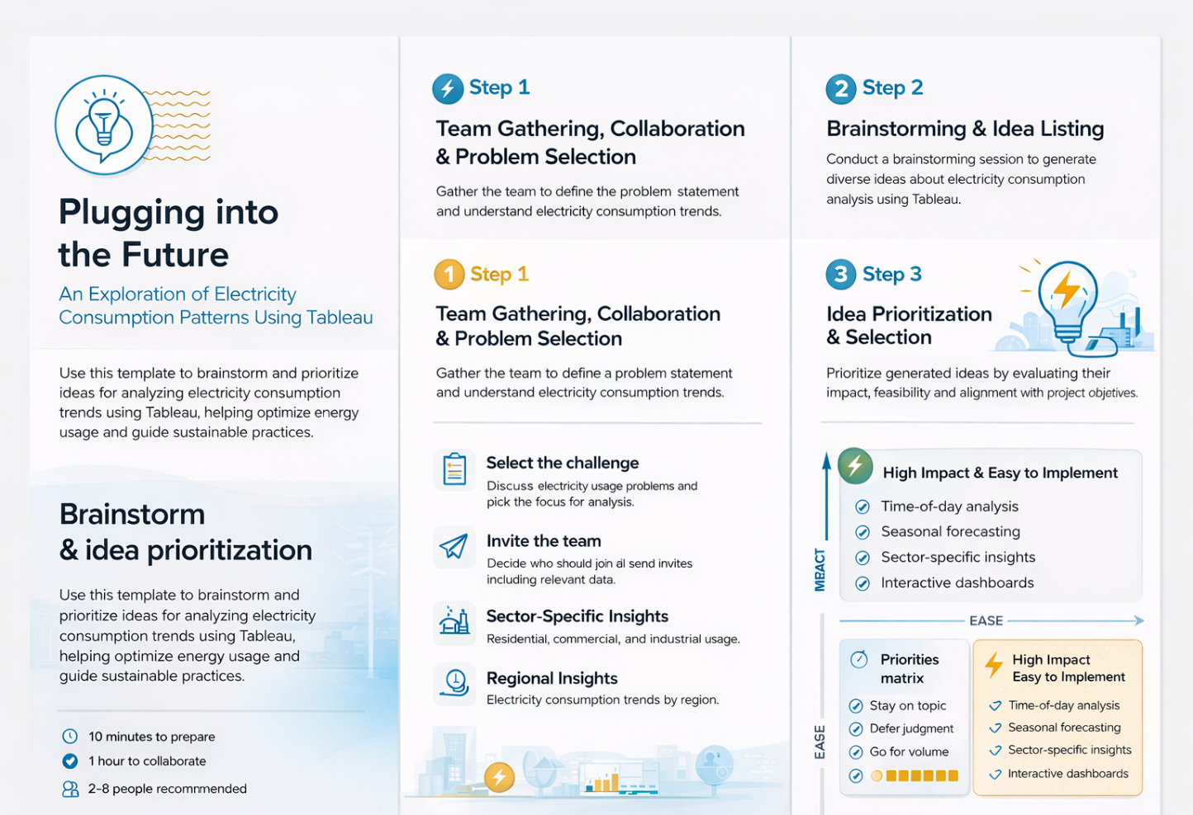

Step-2: Brainstorm, Idea Listing and Grouping
The team brainstormed multiple ideas related to electricity consumption analysis.
Ideas were grouped into categories such as:
- Time-of-day and seasonal usage patterns
- Region-wise and state-wise electricity consumption
- Sector-wise consumption (Residential, Commercial, Industrial)
- Comparative analysis such as Top N and Bottom N states
This step helped organize ideas into meaningful and actionable groups.

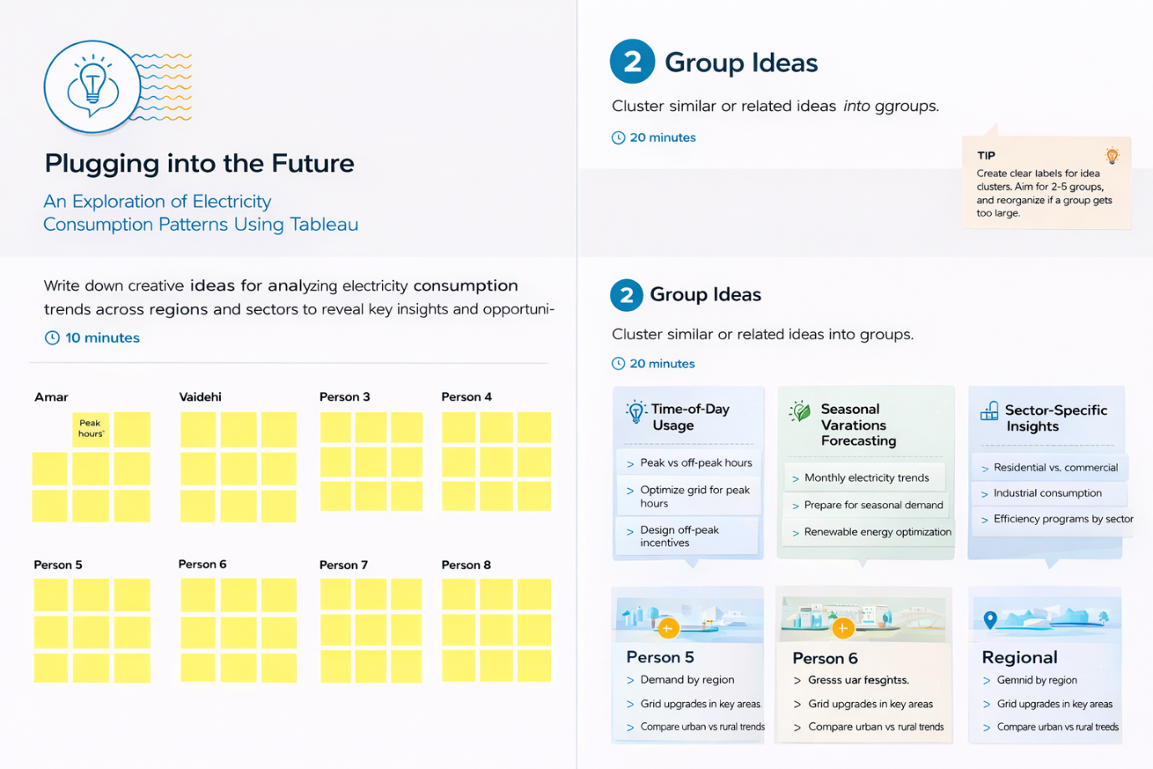

Step-3: Idea Prioritization
The grouped ideas were evaluated using an Importance vs Feasibility matrix.
Ideas with high importance and high feasibility were selected for implementation, including:
- Time-of-day electricity usage analysis
- Seasonal consumption trends
- Sector-wise electricity consumption insights
Low-priority and complex ideas were excluded to keep the project focused and achievable.

